Motion and Forces

Multiple Choice

Select the alternative that most fully and correctly answers the following questions.

1. The diagram below shows forces acting on cars that are moving to the left?
(The size of the force is denoted by the size of the arrow shown.)

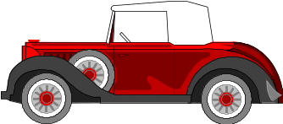
i)
ii)
iii)
iv)

Which car/s would be undergoing non-uniform motion?

A. i), ii) and iv) B. ii), iii) and iv) C. i), ii) and iv) D. All of them

2. Which of the following trolleys would have the greatest acceleration?
A
B
D
C
2 kg
4 kg
2 kg
4 kg
5 N
10 N
10 N
5 N

3. Which of the following statements about forces is true?

A A force applied to the center of mass of an object may cause it to rotate
B When a hammer knocks a nail into wood, the force on the nail must be greater than the force on the hammer head
C A helicopter hovers when the net force on the blades equals the weight of the aircraft
D The forces acting on two weights must be equal if they are both falling with the same acceleration

4. The diagram shows apparatus where a 0.9 kg trolley is being pulled along by a 0.3 kg load on a string over a pulley.

0.3 kg
0.9 kg

Assuming no frictional forces, the acceleration of the trolley will be:

A. 3.33 ms⁻² B. 3.00 ms⁻² C. 2.45 ms⁻² D. 1.95 ms⁻²

5. The string attached to the trolley in Q. 4 would have a tension in it of about:

A. 2.2 N B. 2.9 N C. 5.4 N D. 8.8 N

6. A cannon ball is fired horizontally at a speed of 150 ms⁻¹ from the top of a cliff that is 50 m high.
50 m

How far from the base of the cliff will the cannon ball land?

A. 1500 m B. 970 m C. 650 m D. 480 m
7. Referring to the cannon question previously, the velocity of impact of the cannon ball will be about:

A. 31.3 ms⁻¹ B. 150 ms⁻¹ C. 153 ms⁻¹ D. 171 ms⁻¹

8. A painter walks along a pavement at a speed of 1.5 ms⁻¹ holding a leaking tin of paint. A photograph shows that, in a space of 22 m, there were 11 spots of paint on the ground.
22 m

At this same rate of loss of paint from the tin how long will it take to lose the whole litre of paint from the tin if each paint spot contains 0.3 cm³ of paint?

A. 1.22 h B. 1.35 h C. 1.47 h D. 1.63 h

9. A helical spring has an unstretched length of 13.7 cm. When a load of 72 g is placed on the spring it then measures17.3 cm. What would the length of the spring be if a new load of 120 g was placed on the spring, assuming it stretches in the same manner as before?

A. 15.9 cm B. 19.7 cm C. 22.8 cm D. 36.5 cm

10. A vintage car can accelerate, in 3rd gear, from 80 to 100kmh⁻¹ in 4.0 seconds

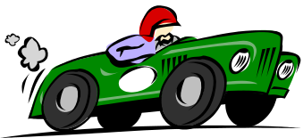

The acceleration, measured in metres per second is about:

A. 1.4 B. 5.1 C. 20.2 D. 25.0

11. The car in the previous question has a mass of 750 kg. This means the force exerted by the engine whilst accelerating must be about:

A. 890 N B. 1.01 kN C. 3.75 kN D. 7.35 kN

12. The forces acting in a system are represented by the vectors a and b below:
a
_
b
_
_

The resultant of these two vectors would be shown by the following vector:

A. B. C. D.

13. Referring to the same vectors in Q 12 the vector displaying the difference between two vectors (i.e. a – b) is:

A. B. C. D.

14. A 200 gram tennis ball strikes the ground at an angle of 40⁰ and a speed of 8.7 ms⁻¹. The ball rebounds at the same angle but with a speed of 5.8 ms⁻¹. The magnitude of the change in velocity of the ball is about:

A. 2.9 ms⁻¹ B. 6.2 ms⁻¹ C. 9.6 ms⁻¹ D. 10.4 ms⁻¹

15. Big Bertha was the name of a huge cannon used by the Germans in the First World War to fire across the Channel to England.
This gun was mounted on a train and could be moved to different positions.
The shell’s muzzle velocity was 750 kmh⁻¹.
40⁰
20 ms⁻¹

If the gun were angled at 40⁰ to the horizontal and moving forward at 20 ms⁻¹ the shell’s velocity measured along the ground would be about:

A. 160 ms⁻¹ B. 180 ms⁻¹ C. 208 ms⁻¹ D. 232 ms⁻¹

16. In one of Gallileo’s famous “thought” experiments he imagined that a cannonball was dropped for the top of the mast of a moving ship.
3 ms⁻¹
22 m
Cannonball

Suppose the boat’s forward speed was 3 ms⁻¹ and the mast was 22 m high, the position that the cannonball would land would be approximately:

A. 6.4 m behind the mast B. 3.2 m behind the mast
C. Directly below the mast D. 6.4 m in front of the mast

17. In a circus act Bimbo, The Human Cannonball, is fired from the muzzle of a cannon that is angled at 60⁰ to the horizontal and sits 3.0 m from the floor.


3 m
60⁰

If Bimbo has a mass of 65 kg and leaves the muzzle of the cannon at a velocity of 20 ms⁻¹ the total energy his body will possess at any time during the flight will be about:

A. 5.1 kJ B. 11.6 kJ C. 22.8 kJ D. 14.9 kJ

18. In the previous question (Q 17), the gun barrel is 3.2 m long. If Bimbo’s acceleration along the barrel is constant during the firing, what acceleration does he experience in “g’s”? (One ‘g’ equals an acceleration of 9.8 ms⁻²)

A. 5.7 g B. 6.4 g C. 7.3 g D. 9.8 g

19. In training, a baseball batter hits a ball at a speed of 27 ms⁻¹ and an angle of 55⁰ towards a vertical metal fence that is 45 m away.

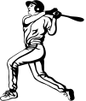
27 ms⁻¹
55⁰
45 m

How far from the ground does his ball strike the fence?

A. 5.7 m B. 13.6 m C. 18.3 m D. 22.9 m

20. The kinetic frictional force on a moving object is given by the formula:

F_{r} = μ R

Where μ = a constant for the surface called “coefficient of kinetic friction”
R = normal reaction of the surface

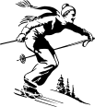
A girl skiing along a flat area is travelling at 5.0 ms⁻¹ and drops her ski stick as she enters a horizontal stretch of snow where the coefficient of friction is 0.06. If her mass is 42 kg, how far will she travel after dropping the stick, before she stops?

A. 19.6 m B. 21 m C. 26 m D. 32 m

21. A Jill and Ben are on their tandem bike and start to accelerate down a ramp with a slope of 30⁰ to the horizontal.

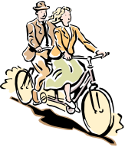
30⁰

The two people and bike have a combined mass of 130 kg and the frictional force on the wheels is 83 N. The acceleration the bike will have down the hill will be about:

A. 9.8 ms⁻² B. 4.9 ms⁻² C. 4.3 ms⁻² D. Zero

22. Two tugs are pulling a large ocean liner out to sea on ropes. Tug A exerts a force of 51 kN at an angle of 30⁰ to the forward direction and tug B exerts a force of 68 kN at angle of 60⁰.
TUG A (51 kN)
TUG B (68 kN)
LINER
30⁰
60⁰
FORWARD DIRECTION

The resultant force on the liner due to the tugs is about:

A. 85 kN B. 92 kN C. 119 kN D. 123 kN

23. Due to the tugs pulling the liner in the last question (Q 25) the liner will start to move at an angle to the forward direction of about:

A. 53.1⁰ B. 36.8⁰ C. 23.1⁰ D. Zero degrees

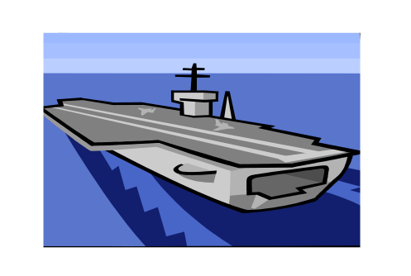
24. The catapult launching aid system on an aircraft carrier is a mechanical device that accelerates jet fighters across the deck up to take-off speed in quite a short distance.
A jet has a mass of 1700 kg and needs to achieve a take-off speed greater than 225 kmh⁻¹. This is achieved with a catapult system capable of pulling the jet with a force of 50 kN. With these requirements, the minimum distance along the deck needed for a successful take-off would be about:

A. 48 m B. 66 m C. 82 m D. 98 m
25. A man drives his car for 30 minutes on a major road at 70 kmh⁻¹ and into the country. He then stops for 30 minutes for a tea break then travels North on a country road for 1½ hours at a speed of 110 kmh⁻¹ to complete his journey. The man’s average speed over the whole journey is about:

A. 106 kmh⁻¹ B. 91 kmh⁻¹ C. 78 kmh⁻¹ D. 87 kmh⁻¹

26. Which of the following graphs applies for an accelerating object?

Displacement
Displacement
Velocity
Velocity
Time
Time
Time
Time
i)
ii)
iii)
iv)

A. i), ii), iii) B. i), iv) C. iii), iv) D. i), iii), iv)

27. A girl cycles a total distance of 36 km one morning in 90 minutes.
Her average speed (in ms⁻¹) for the journey would be about:

A. 7 ms⁻¹ B. 8 ms⁻¹ C. 9 ms⁻¹ D. 10 ms⁻¹

28. A man’s cap falls off his head onto the ground.
Assuming zero air resistance, the time before it hits the ground will be about:

A. 0.2 s B. 0.4 s C. 0.6 s D. 0.8 s

29. A boy leaning out of his top-floor window one day accidentally knocks a flowerpot from the windowsill and he hears the sound of the crash 2.5 s later. The boy can use this time to calculate the height of his window. What is the approximate height of the windowsill above the ground?

A. 25 m B. 30 m C. 35 m D. 40 m

30. In the last question the boy realizes that in his calculations for height (h) he has neglected the effect of air resistance and also the time it took for the sound to travel to his ear. A better value for h could be obtained by allowing for the following:

 | Allowing for the speed of sound | Allowing for air resistance
A | Time should be shorter than measured, true h would be smaller | Time should be longer than measured, true h would be larger
B | Time should be longer than measured, true h would be smaller | Time should be shorter than measured, true h would be larger
C | Time should be shorter than measured, true h would be smaller | Time should be longer than measured, true h would be larger
D | Time should be longer than measured, true h would be larger | Time should be shorter than measured, true h would be smaller

31. A truck driver on the top of a hill lets his hand brake off in neutral gear so that his truck drifts 150m down the hill to a level road. Near to the bottom he realizes that he cannot stop and will need to use the emergency slip road track at the bottom filled with sand

Emergency sand pit
30⁰
150 m

The distance down the hill from the top is 150 m and it has a slope of 30⁰.
The speed of the truck down the slope as it hits the sand will be about:

A. 22.6 ms⁻¹ B. 38.3 ms⁻¹ C. 54.2 ms⁻¹ D. 61.3 ms⁻¹

32. In the last question the sand has a resistive force of 100 kN against the wheels of the truck which has a mass of 5.5 tonnes. The distance the truck travels in the sand before it stops is about:

A. 40 m B. 56 m C. 60 m D. 71 m

33. A male bag-snatcher grabs a woman’s purse in the park and runs across the grass at a constant speed of 5.5 ms⁻¹. An athletic girl looks around, sees the man and starts to run after him with an acceleration of 2.5 ms⁻² just as he passes her. The girl reaches her maximum speed of 7 ms⁻¹ and continues at that speed until she eventually catches him. How far in front of her starting position does she catch the man?

A. 28 m B. 32 m C. 36 m D. 41 m

34. Romeo throws from his hand 1.5 m above the ground at an angle of 75⁰ to the horizontal. On his third attempt he just manages to get the gift to go over the parapet of the balcony which is 1.2 m high.



8 m
1.2 m
1.5 m

At what approximate speed does he need to throw the gift?

A. 12.3 ms⁻¹ B. 12.7 ms⁻¹ C. 13.5 ms⁻¹ D. 13.9 ms⁻¹

35. A bucket is accidentally knocked from a 65 m high building. When the bucket is 14 m from the ground a worker below looks up and notices it directly above him. If he is 1.8 m tall how much time does the man have to get out of the way?

A. 0.11 s B. 0.18 s C. 0.29 s D. 0.37 s

36. A jet of water strikes the curved blade of a turbine at a speed of 20 ms⁻¹ and returns in the opposite direction at the same speed. The mass of water striking the blade per second is 32 kg.
V = 20 ms⁻¹
V = -20 ms⁻¹
Turbine
blade

The magnitude of the force on the blade due to the water is about:

A. 940 N B. 1.3 kN C. 1.9 kN D. 2.7 kN




37. A jet fighter moving at 720 kmh⁻¹ flies over a nomad tribesman in the desert holding his rifle in the air. The man fires his gun at the aeroplane when it is directly overhead.

If the muzzle velocity of the rifle is 420 ms⁻¹, at what angle must the tribesman aim if he is to hit the jet?

A. 58.2⁰ B. 61.6⁰ C. 68.9º D. 72.3⁰

38. If the jet was 900 m above the tribesman when he fired, at what approximate horizontal distance from the man will the bullet hit the aeroplane.

A. 350m B. 490 m C. 600 m D. 740 m

39. As a stunt for the circus, Eric the Bikie drives up a 20⁰ ramp and flies over the top of four buses to land on another ramp on the other side. The gap to jump is 35 m wide.
20⁰

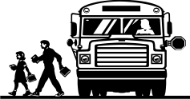
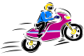
35 m

For Eric to perform this stunt his minimum speed must be about:

A. 23 ms⁻¹ B. 28 ms⁻¹ C. 34 ms⁻¹ D. 37 ms⁻¹

40. To raise a 550 kg car engine out of the chassis Ben lifts it with a pulley system while Bill pulls it sideways by another rope so it clears the body. The diagram above shows an instant when Ben’s top rope is at an angle of 15⁰ to the vertical and Bill’s rope is horizontal.


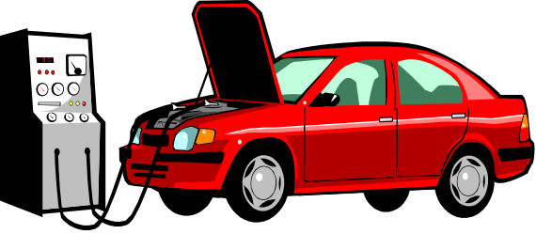

Bill
Ben
15⁰

The force needed by Bill to hold the engine in equilibrium in this position is about:

A. 980 N B. 1.4 kN C. 3.4 kN D. 5.6 kN

